2017 Backyard BBQ Competition Team Registration
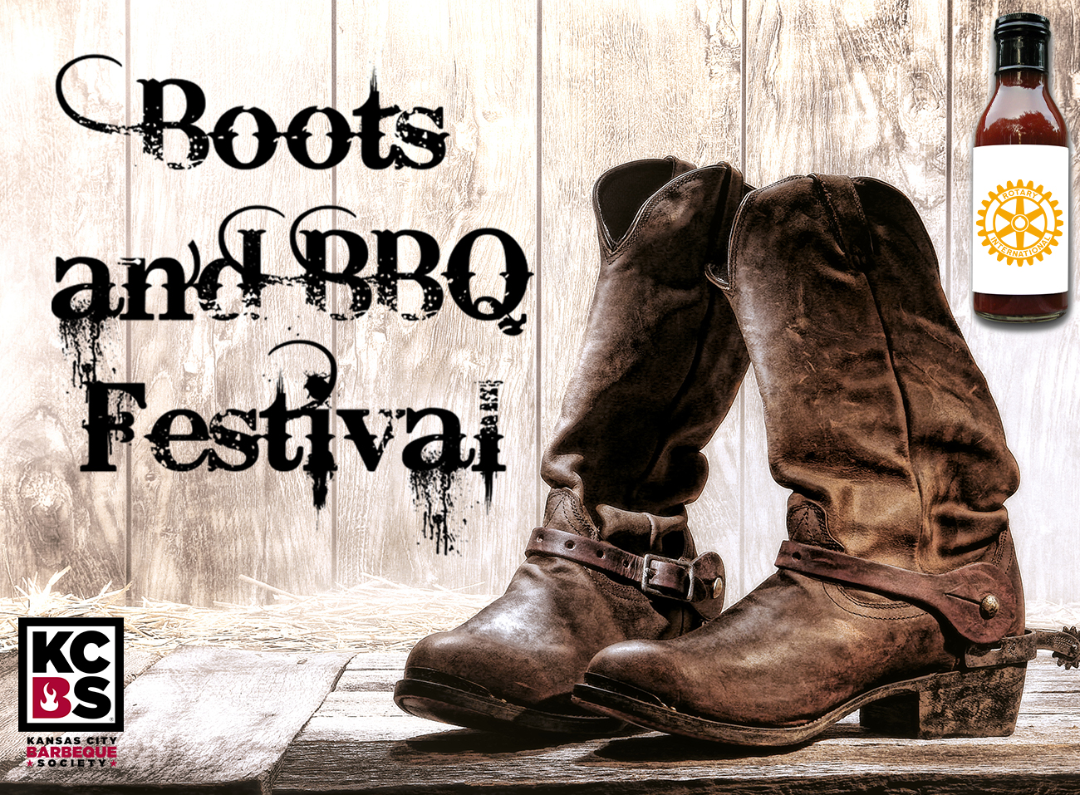
Registration Fees: $75 per team if registered by
June 2, 2017
Registration Fees: $100 per team if registering the day
Of

Team Name: ________________________________________________________

Team Captain: _______________________________________________________

Team Address: _______________________________________________________

City, State & Zip Code: ________________________________________________

Team Phone: _______________ Alternate Phone: ______________

Team email: ______________________

*Electricity is on a first come, first serve basis.
The following must be included to complete your registration and guarantee participation in the 2017 Boots and BBQ Festival Backyard BBQ Competition:
- Team Registration complete
- Full Payment made out to: Claremore Reveille Rotary (Payment may be made by cashier’s check, personal check or money order)
- Mail both payment and registration to: Reveille Rotary, PO Box 1653; Claremore, OK 74018-1653
- To register by phone, contact Tanya Andrews, Claremore Expo Center at 918-342-5357; credit card payment is expected at the time of registration.
Contact:
Tanya Andrews: 918-341-8688 or email Tandrews@claremorecity.com
Backyard BBQ Competition Rules:
- Teams can check-in Friday, June 2 from 10:00 am to 6:00 pm or at 6:00 am on June 3.
- Cooks meeting will be Friday, June 2, at 6:00 pm.
- Teams will be assigned their space upon check-in. It is first come, first serve.
- Meat categories are beef (open), pork ribs (must be cut apart) or pork butt, and chicken (No Cornish Game Hens). Judging will begin at noon on Saturday.
- Hammonship and booth judging (themes or decorations) will begin at 11:00 am.
- Awards will be announced at 3:30 pm.
- Taster kits will be available to the public, for a donation, so we encourage you to cook extra. (Proceeds benefit special projects of the Reveille Rotary Club of Claremore). No food or drinks can be sold by teams; these will be available by paid vendors of the Rotary club.
- All meat must be raw and uncooked at check-in. Prior preparation, such as marinating and seasoning is permitted.
- Electric is available, but limited. Water will be nearby cook’s area.
- Vehicles will be allowed to drive in for set up, but must be moved by 7:00 am.
- All equipment, trash, vehicles must load out by 5:00 pm (no exceptions).
- Each team will be required to have a fire extinguisher in view at all times.
- Winner of the 2016 Backyard BBQ Competition will participate in the 2017 Boots and BBQ, only in the KCBS competition.

Trophies will be awarded to 1st, 2nd, and 3rd place winners in each of these categories: Beef, Pork, Chicken, and Hammonship.

